Module 2 – Frontend – HTML
HTML Basics
Theory Assignment:
Q.1 Define HTML. What is the purpose of HTML in web development?
Ans:- HTML (Hyper Text Markup Language) is the standard markup language used to create and structure web pages.
It uses tags (like <html>, <head>, <body>, <p>, <img>) to tell a web browser what content is on the page and how it is organized.
- Purpose of HTML in web development :
- Structure Web Content
  - Defines headings, paragraphs, lists, tables, forms, images, and links
  - Example: <h1> for headings, <p> for paragraphs
- Create Web Pages
  - Every website page you see on the internet is built using HTML
- Link Pages Together
  - Uses hyperlinks (<a> tag) to connect multiple web pages
- Embed Media
  - Allows embedding images, videos, audio, and other multimedia content
- Work with CSS and JavaScript
  - HTML → structure
  - CSS → design & layout
  - JavaScript → interactivity
Together, they form a complete website.
- Ensure Browser Compatibility
  - All web browsers understand HTML, making it universal for the web
Q.2 Explain the basic structure of an HTML document. Identify the mandatory tags and their purposes.
Ans:- An HTML document follows a fixed structure so that browsers can correctly read and display the content. Every HTML page is built using tags, written inside angle brackets < >.
Example:-
<!DOCTYPE html>
<html>
<head>
<title>My First Web Page</title>
</head>
<body>
<h1>Hello World</h1>
<p>This is my first HTML page.</p>
</body>
</html>
- <!DOCTYPE html>
- Purpose: Tells the browser that this document is written in HTML5
- Why important: Ensures the browser renders the page correctly
- Note: It is not a tag, but a declaration
- <html>
- Purpose: Root (main) element of the HTML document
- Why important: Wraps all HTML content

<head>
- Purpose: Contains metadata (data about the page)
- Used for:
  - Page title
  - CSS styles
  - Meta tags
  - SEO info
- Not displayed on the web page

<title>
- Purpose: Sets the title of the webpage
- Shown in:
  - Browser tab
  - Search engine results

<body>
- Purpose: Contains visible content of the webpage
- Examples of content:
  - Text
  - Images
  - Links
  - Buttons
Q.3 What is the difference between block-level elements and inline elements in HTML? Provide examples of each.
Ans:- Block-Level Elements
Block-level elements start on a new line and take up the full width available (by default).
- Always start on a new line
- Stretch from left to right (100% width)
- Can contain inline elements and other block elements
- Height and width can be set

Common Block-Level Elements
- <div>
- <p>
- <h1> to <h6>
- <ul>, <ol>, <li>
- <section>
- <article>
- <header>
- <footer>
- <form>
Example
<div>
<h1>Welcome</h1>
<p>This is a block-level paragraph.</p>
</div>
📝 Each element appears on a new line.
- Inline Elements
Inline elements do not start on a new line and only take up as much width as necessary.
- Do NOT start on a new line
- Take only required width
- Usually used inside block-level elements
- Height and width cannot be set directly

Common Inline Elements
- <span>
- <a>
- <strong>
- <em>
- <img>
- <label>
- <input>
- <i>
- <b>
Example
<p>
This is an <span>inline</span> element inside a paragraph.
</p>

Q.4 Discuss the role of semantic HTML. Why is it important for accessibility and SEO? Provide examples of semantic elements.
Ans:- Semantic HTML means using HTML elements that clearly describe their meaning and purpose—both to the browser and to developers.
Instead of using generic tags like <div> and <span> everywhere, semantic HTML uses meaningful tags such as <header>, <nav>, <article>, etc.
Role of Semantic HTML
Semantic HTML plays a crucial role in:
- Accessibility
- Search Engine Optimization (SEO)
- Code readability & maintenance
- Better browser and device interpretation
Importance for Accessibility
Semantic elements help screen readers and assistive technologies understand the structure of a web page.
Why it matters:
- Screen readers can identify navigation, main content, and sections
- Users with disabilities can navigate faster and more accurately
- Improves experience for keyboard-only users

Example
<nav>
<a href="#home">Home</a>
<a href="#about">About</a>
</nav>

Importance for SEO
Search engines (like Google) use semantic HTML to understand page content and hierarchy.
Benefits for SEO:
- Clear identification of main content
- Better understanding of headings and sections
- Improved indexing and ranking
- Rich search results (featured snippets)

Example
<article>
<h1>How SEO Works</h1>
<p>SEO helps improve website visibility.</p>
</article>

Lab Assignment:
Create a simple HTML webpage that includes:
⇒ A header (), footer (), main section (), and aside section ().
⇒ A paragraph with some basic text.
⇒ A list (both ordered and unordered).
⇒ A link that opens in a new tab.
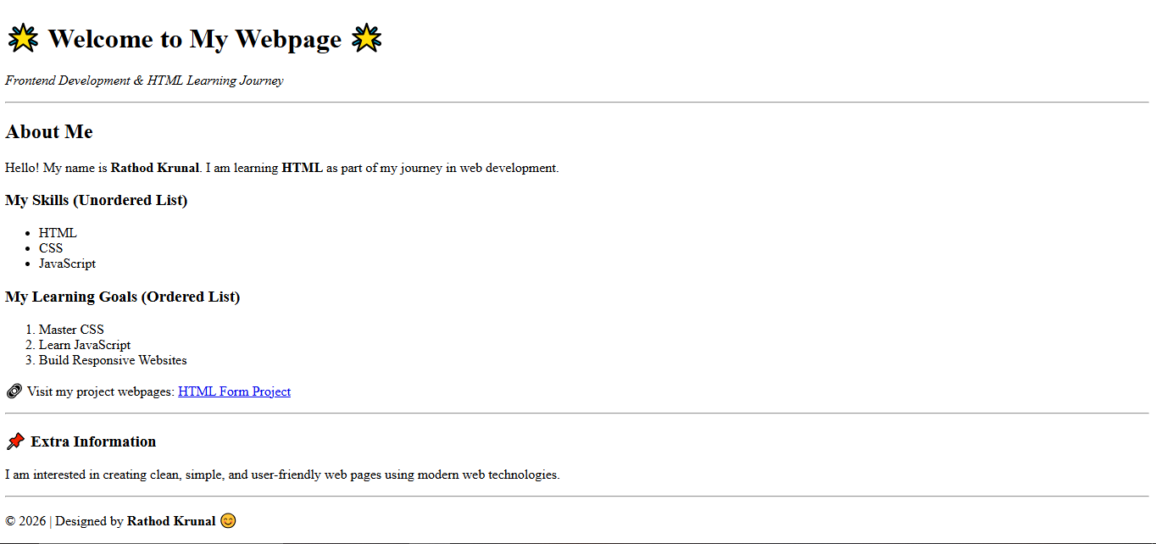

HTML Forms
Theory Assignment:
Q.1 What are HTML forms used for? Describe the purpose of the input, textarea, select, and button elements.
Ans:- HTML forms are used to collect input/data from users and send it to a server for processing.
Common uses of HTML forms:
- Login and registration pages
- Contact forms
- Feedback and surveys
- Search boxes
- Online orders and payments
Forms allow users to enter information and interact with websites.
Purpose of Form Elements:
- <input> Element
- Used to collect single-line user input
- Can take different types of data
Examples of input types:
- text → Name, username
- email → Email address
- password → Password
- radio → Select one option
- checkbox → Select multiple options
- <textarea> Element
- Used to collect multi-line text
- Ideal for long messages or descriptions

<select> Element
- Used to create a drop-down list
- Saves space and limits user choices

<button> Element
- Used to submit, reset, or trigger an action in a form
Common button types:
- submit → Sends form data
- reset → Clears the form
Q.2 Explain the difference between the GET and POST methods in form submission. When should each be used?
Ans:-
Feature | GET Method | POST Method
Data Location | Appended to the URL as query parameters. | Included in the HTTP request body.
Data Visibility | Data is visible in the browser's address bar and history. | Data is not visible in the address bar.
Data Size | Limited data size (varies by browser/server, typically a few KB). | No practical limit on data size.
Bookmarking | Submissions can be bookmarked/shared via the URL. | Submissions cannot be bookmarked/shared directly.
Security (Sensitive Data) | Less secure; data is exposed in the URL. | More secure for sensitive data.

Q.3 What is the purpose of the label element in a form, and how does it improve accessibility?
Ans:- The <label> element is used to describe or name a form control such as an input, textarea, or select field.
How does <label> improve accessibility?
  - Helps Screen Readers
- Screen readers read the label text when the input field is focused
- Visually impaired users understand what the field is for
  - Increases Clickable Area
- Clicking on the label automatically focuses or selects the related input
- Very helpful for radio buttons and checkboxes
  - Improves Form Usability
- Makes forms easier to understand
- Reduces user errors
  - Supports Semantic HTML
- Clearly connects text with form controls
- Improves overall accessibility compliance
Lab Assignment:
Task: Create a contact form with the following fields:
⇒ Full name (text input)
⇒ Email (email input)
⇒ Phone number (tel input)
⇒ Subject (dropdown menu)
⇒ Message (textarea)
⇒ Submit button

Additional Requirements:
⇒ Use appropriate form validation using required, minlength, maxlength, and pattern.
⇒ Link form labels with their corresponding inputs using the for attribute.
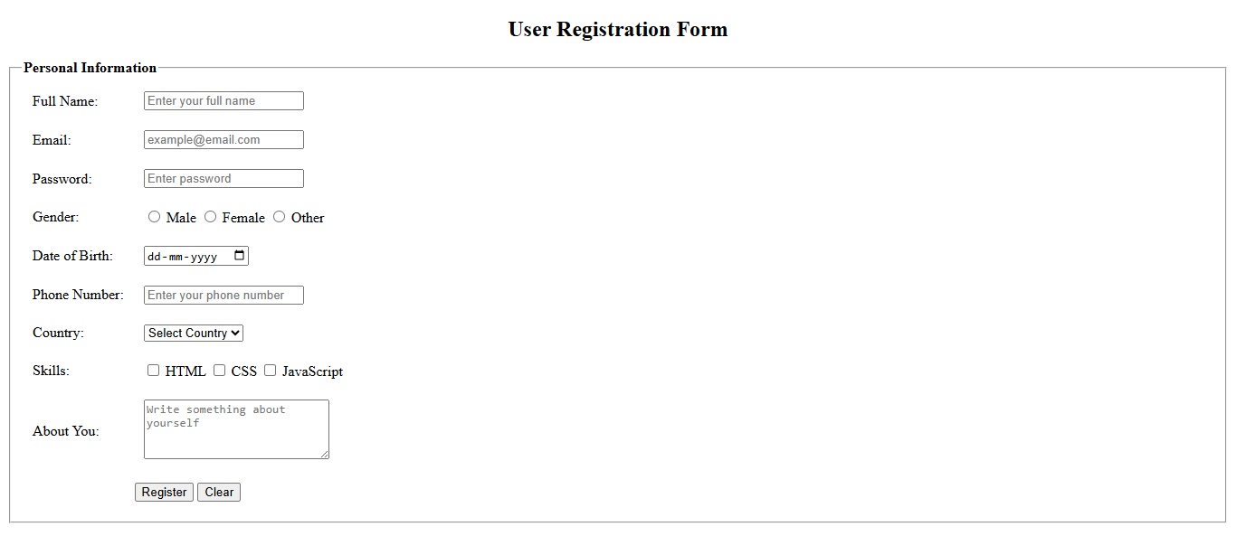
HTML Tables
Theory Assignment:
Q.1 Explain the structure of an HTML table and the purpose of each of the following elements: <table>,<tr>,<th>,<td> and <thead>.
Ans:- An HTML table is used to display data in a row-and-column format, similar to a spreadsheet.HTML provides specific elements to define the structure, headings, and data inside a table.
Example:-
<table>
<thead>
<tr>
<th>Name</th>
<th>Age</th>
<th>City</th>
</tr>
</thead>
<tr>
<td>Rahul</td>
<td>22</td>
<td>Delhi</td>
</tr>
</table>

<table>
- Purpose: Creates the table container.
- Holds all rows, headings, and data cells.
- Without <table>, other table elements cannot exist.

<tr> (Table Row)
- Purpose: Defines a single row in a table.
- Can contain <th> or <td> elements.
- Each <tr> represents one horizontal row.

<th> (Table Header Cell)
- Purpose: Defines a heading cell.
- Text is bold and centered by default.
- Improves accessibility and SEO.
- Usually placed inside <thead>.

<td> (Table Data Cell)
- Purpose: Holds actual table data.
- Appears under table headers.
- Text is normal-weight and left-aligned by default.

<thead>
- Purpose: Groups header rows of the table.
- Contains <tr> with <th> elements.
- Helps browsers, screen readers, and CSS understand table structure.
- Useful for large tables and printing.

Q.2 What is the difference between colspan and rowspan in tables? Provide examples.
Ans:- HTML Table - Rowspan
To make a cell span over multiple rows, use the <rowspan> attribute:
<table border="1">
<tr>
<th>Name</th>
<th>Subject</th>
<th>Marks</th>
</tr>
<tr>
<td rowspan="2">Krunal</td>
<td>HTML</td>
<td>85</td>
</tr>
<tr>
<td>CSS</td>
<td>80</td>
</tr>
</table>
HTML Table – Colspan
<colspan> is used when one table cell spans multiple columns.
<table border="1">
<tr>
<th colspan="3">Student Marks</th>
</tr>
<tr>
<th>Name</th>
<th>Subject</th>
<th>Marks</th>
</tr>
<tr>
<td>Krunal</td>
<td>HTML</td>
<td>85</td>
</tr>
</table>

Q.3 Why should tables be used sparingly for layout purposes? What is a better alternative?
Ans:- Tables were originally designed to display tabular data, not to build page layouts. Using tables for layout causes several problems:
  - Poor Accessibility
- Screen readers have difficulty understanding layout tables
- Confuses users who rely on assistive technologies
  - Less Flexible Design
- Table-based layouts are rigid
- Difficult to make pages responsive for mobile and tablets
  - Harder to Maintain
- Nested tables make code complex and messy
- Small layout changes require editing many rows and columns
  - Slower Page Loading
- Browsers must load the entire table before displaying it
- Affects performance, especially on slow networks
  - Violates Semantic HTML Principles
- Tables do not describe the meaning of content
- Reduces code readability and SEO quality

Lab Assignment:
Create a product catalog table that includes the following columns:
⇒ Product Name
⇒ Product Image (use placeholder image URLs)
⇒ Price ⇒ Description
⇒ Availability (in stock, out of stock)
Additional Requirements:
⇒ Use thead for the table header.
⇒ Add a border and some basic styling using inline CSS.
⇒ Use colspan or rowspan to merge cells where applicable.
